Name
____________________
____________________
____________________

My Pet is a:
- Dog
- Cat

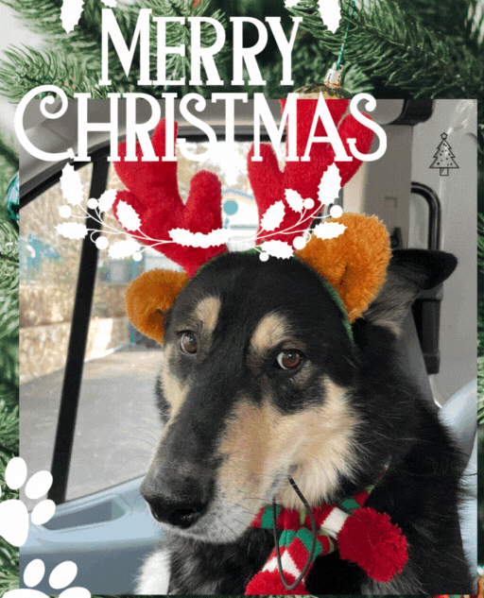

And would like a:
Toy
- Stuffed
- Hard

- Collar
or
- Harness
- Small
- Medium
- Large

- Bowl
- 1
- 2
- 3
- Small
- Medium
- Large

- Bed*
- Small
- Medium
- Large

*Limited supply on beds. First come, first served.

